A
PROJECT REPORT
ON
INTENSITY CARE OF MOTHER AND KIDS

Submitted to Jai Narain Vyas University for the partial fulfillment of the requirement for the award of the degree of

BACHELOR OF SCIENCE INFORMATION TECHNOLOGY

WORK CARRIED OUT AT

S.P.U.(P.G.) COLLEGE, FALNA

For the Academic Year 2011-2014

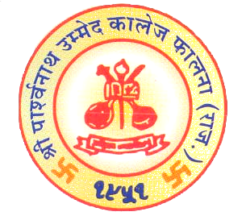

Submitted by:

LALIT KUMAR
DEEPAK KUMAR
RAVINDRA SINGH RAO

Internal-Guide Dr. Y Sharma
Mr. Purushottam Bhaskar Head of the Department
(Department of Computer Science)

S.P.U.(PG) COLLEGE

Department of computer science
JNVU, JODHPUR
Falna -Rajasthan

